ECON1064 – Forecasting and Quantitative Analysis
Assessment 2: Group Assignment
Instructions:
This project is designed to acquaint students with the application of forecasting techniques in business. This involves planning research, collecting data, carrying out appropriate tests, analysing data using regression analysis, and writing a business report based upon this empirical work. You will also deliver a pre-recorded oral presentation to communicate the key findings.
The assignment needs to be completed as a group of 3-4 students officially registered on Canvas. In exceptional circumstances, you may be allowed to complete it individually.
Scope: maximum of 6 pages submitted (excluding cover sheet, Report title page, Report index (optional), References and appendix) + a pre-recorded oral presentation.
Submission: Via Assignments folder in Canvas. Only one submission is required per group. It is very important that you submit an assignment cover sheet with all the group members’ signatures/names at the time of submission. All students listed on the cover sheet will receive the same mark. If any dispute arises on your contribution to the group work, the cover sheet will be used as evidence of contribution.
Group Work Guide: Students must adhere to the Group Work Guide, found on Canvas. The Guide highlights the guidelines for group participation and the circumstances when a peer evaluation will be required.
Marks: This project comprises 100 marks and will contribute 50% to your overall grade.
Presentation Instructions:
Your written professional report should comply with the following presentation standards:
- Typed using a standard professional font type (e.g. Times Roman), 12-point font size.
- 1.5-line spacing, numbered pages, and clear use of titles and section headings. Where relevant, round to 3 decimal places.
- Graphs and tables should be clearly labelled and presented.
- Well-presented and coherent with no spelling, typographical and grammatical errors.
- Delivered as a Word (.doc or .docx) or PDF (.pdf) file.

You are also required to submit a group presentation recording as follows:
- The presentation should have no more than 5 slides (including the title/contribution slide) and should last not more than 3 minutes.
- The presentation needs to be recorded in PowerPoint (MP4 format), with the camera on.
- The slides need to be submitted either as PowerPoint (.pptx) or PDF (.pdf) file.

Problem description:
The stock market can have a profound economic impact on the economy and individual consumers. Financial analysts and economists are often interested in analysing and predicting stock price movements. One basic analysis is modelling the relationship between future and past (lagged) stock returns of individual companies. If an accurate prediction of future stock prices can be made based on past values, the monetary benefits can be substantial. You and your team members have recently been hired as financial analysts by Fortuna Capital Management. Your first assignment is to examine and forecast a company’s stock price movements.
Data: Your first task is to find and download the relevant data. To do this, you will need to go to the Investing.com - Stock Market Quotes & Financial News website and search for the required data. You may choose a US listed company as well if you wish. Here are a few pointers to help you collect your data:
1) Choice of company: You will need to pick a company you are interested in exploring. The choice is yours – you can choose any company listed on the Singapore or Australian (or US) stock exchange (just check the company has the required data on the website).
2) Time interval: Here you will need to choose between daily, weekly, or monthly data. You can use any or all these time intervals.
3) Timeframe: You will work with the most recent data and determine the time period, which will depend on the time interval(s) you have chosen in 2). We recommend data from the past 6 months as minimum for daily data (longer for weekly or monthly).
Once you have selected your 1) company, 2) time interval/s, and 3) timeframe, you can download the data from the Investing.com - Stock Market Quotes & Financial News website. If you click on Markets>>Stocks it'll take you to the data webpage. You may also like to change the 'World Markets' option to, say, Singapore. The data you will download will have an extension csv.
IMPORTANT: Say you choose to work with Singapore Airlines stock data. The data will be available under the ‘Historical data’ tab. By default, the most recent data is at the top. If you click on “Date”, it will reverse the order. Next, you will need to set the frequency to ‘daily’, ‘Weekly’, or ‘monthly’ for you chosen time period, and press Apply before you download your dataset (download button is just below ‘Apply’).
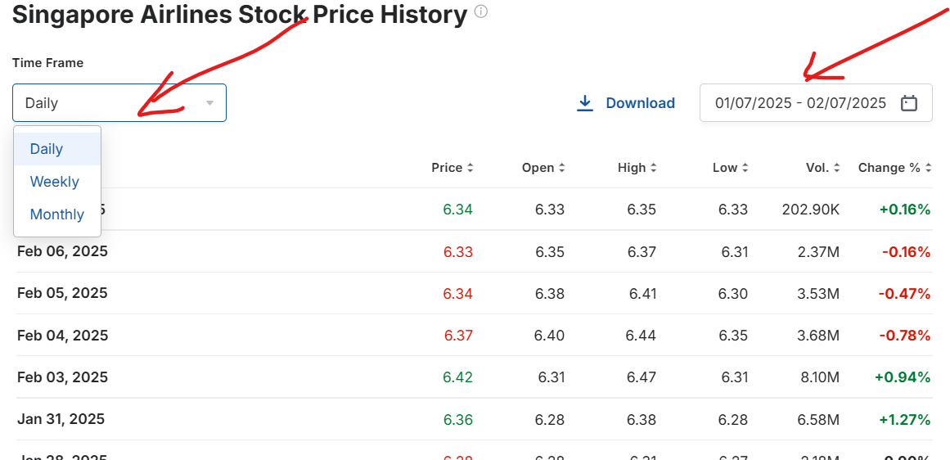
Your next task is to calculate daily/weekly/monthly returns for the Open prices (which is the opening price for the day/week/month and is also the last recorded price for the previous day/week/month). Recall that RETURN is calculated as:
$$\frac{\text{Price in current period-Price in previous period}}{\text{Price in previous period}}$$
For example, if weekly time interval is used: Weekly Return = (Price in current week – Price in the previous week)/Price in the previous week. For example, given the below table, returns for the week starting 7/01/2018 is calculated by: (6122.3-6065.1)/ 6065.1=0.009431. You can name this variable as “RET”. You can also create lagged returns (RETLAG) as this is just the return from the previous week:
Date | Open | RET | RETLAG
31/12/2017 | 6065.1
7/01/2018 | 6122.3 | 0.009431
14/01/2018 | 6070.1 | -0.00853 | 0.009431
21/01/2018 | 6005.8 | -0.01059 | -0.00853

You can now begin your analysis. [Note: Questions need to be answered in the order they have been asked, with appropriate headings for different sections in the Report.]
Grading: 85 marks for statistical analysis and report (including presentation) + 15 marks for oral presentation
Required:
- Start your business report with a formal introduction stating the background of the company, why you are studying its stock price movements, and what is the objective of your analysis. Discuss your choice of time interval/s (daily, weekly, monthly), and the time period. [You are encouraged to cite any relevant media, website and/or journal articles.] (15 marks)
- Conduct a preliminary analysis on your stock returns data: 1) present your data graphically and discuss the results; 2) explain whether transformation/ adjustment/ decomposition is needed for your data (note you don't need to transform/ adjust/ decompose the data, just to explain what is required); 3) plot the ACF of the company’s returns and discuss. Do the returns look like white noise? Explain your answer. (20 marks)
- Continuing the preliminary analysis, calculate and present some key descriptive statistics for the stock returns, and discuss the results. (15 marks)
- In this section you are required to use regression analysis to test the predictive power of past returns (RETLAG) on future returns (RET). Present the regression output and write down the regression equation, specifying the X and Y variables. Create a table that summarises the following key measures of your regression analysis –adjusted R-Squared, the slope parameter, and the P-Value of the slope. Discuss your results, commenting on each of the measures. (20 marks)
- Summarise your findings and provide conclusions. Include any relevant recommendations that you believe could improve your analysis. In particular, discuss variables and methods that you can potentially use to obtain better forecasts. (15 marks)
Note: You need to ensure that your work is well-presented. Marks will be deducted if the assignment does not meet acceptable presentation standards (e.g., unclear layout, missing labels, graphics that are difficult to read, or inconsistent formatting).

Oral Group Presentation (15 marks)
Each group is required to submit a pre-recorded oral presentation along with a slide deck (maximum of 5 slides, including the title and contribution slide).
- All group members must participate in the presentation.
- Your camera must be turned on in the presentation.
- The title slide must clearly outline each member’s role and contribution to the assignment.
- The presentation should clearly communicate the objective of the project and highlight key findings, visuals (e.g. graphs), and conclusions. There is no need to discuss the process.

